**MANUAL OVERTIME ADJUSTMENT**

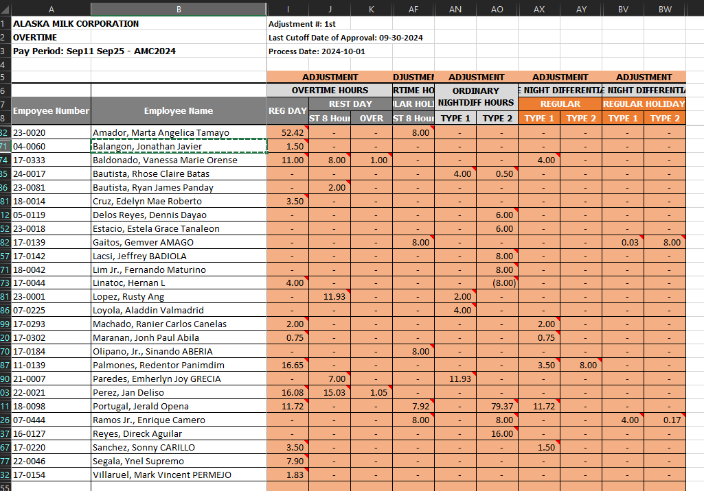

* Balangon, Jonathan Javier - Aligned with the manual adjustment



* Baldonado, Vanessa Marie Orense – Aligned with the manual adjustment

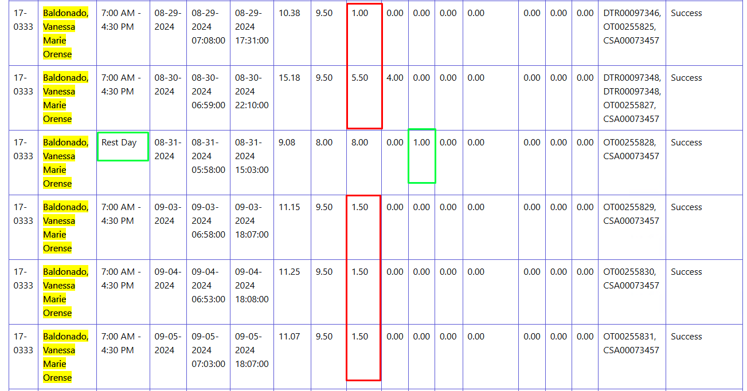

* Bautista, Rhose Claire Batas (May nilalabas sya na mga negative values na dapat wala)



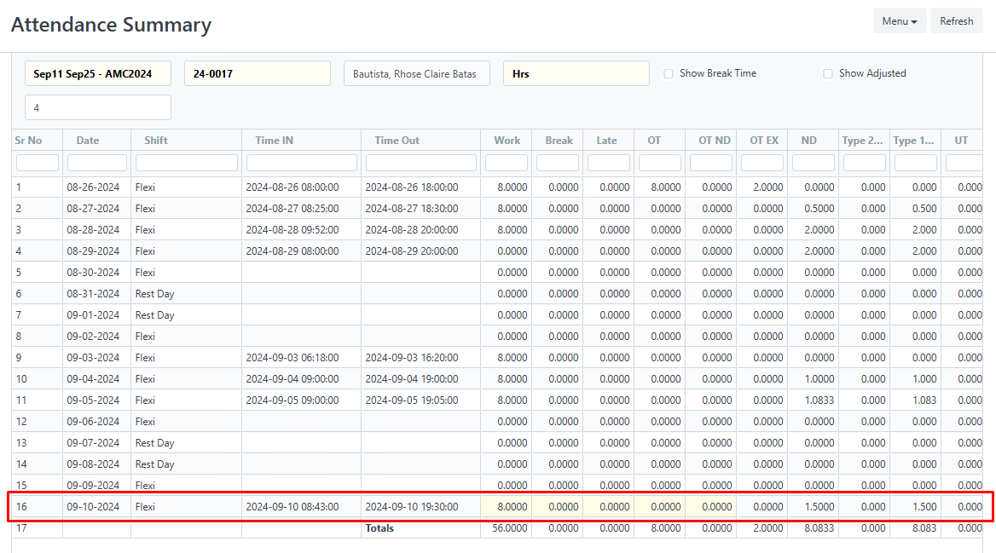

* Bautista, Ryan James Panday (Rest day on Sep 7) yung red may negative sya

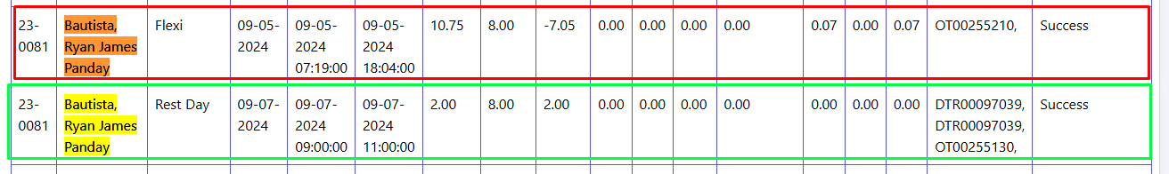

* Cruz, Edelyn Mae Roberto - Aligned with the manual adjustment

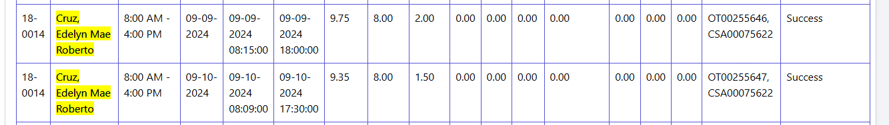

* Lacsi, Jeffrey BADIOLA - Aligned with the manual adjustment



* Lim Jr., Fernando Maturino - Aligned with the manual adjustment
* Linatoc, Hernan L - Aligned with the manual adjustment

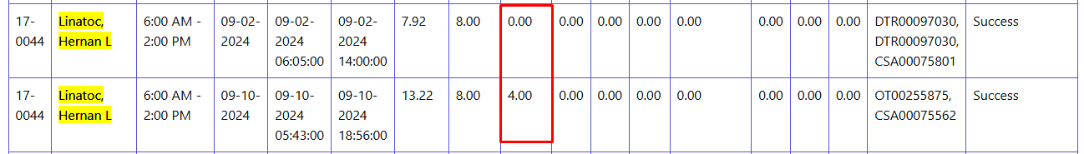

* Loyola, Aladdin Valmadrid - Aligned with the manual adjustment



* Machado, Ranier Carlos Canelas - Aligned with the manual adjustment
* Maranan, Jonh Paul Abila - Aligned with the manual adjustment



* Olipano, Jr., Sinando ABERIA - Aligned with the manual adjustment



* Paredes, Emherlyn Joy GRECIA - Aligned with the manual adjustment



&

* Negative Values

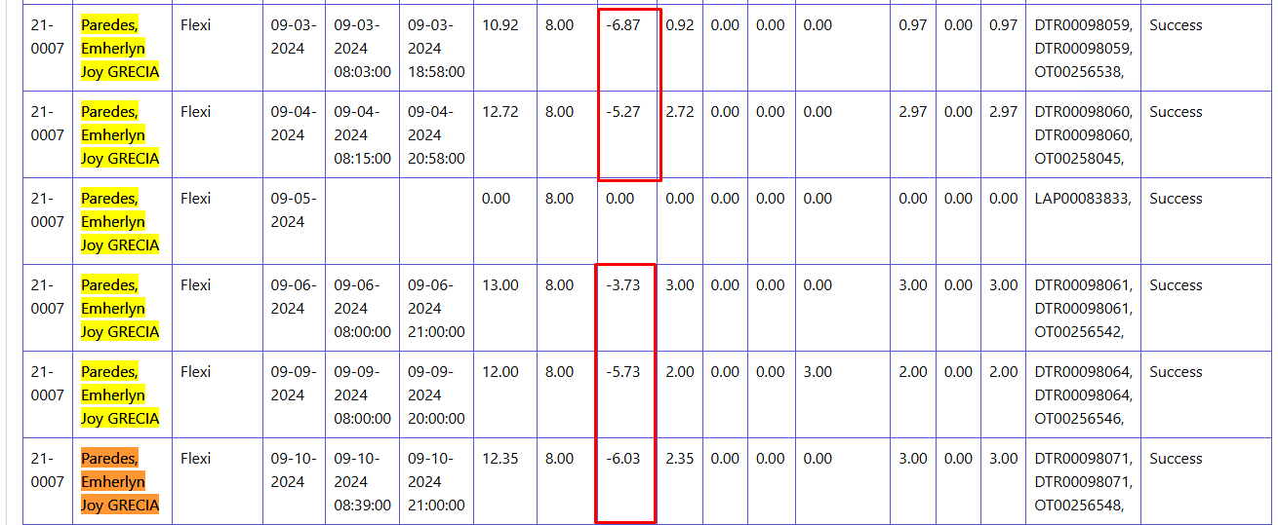

* Perez, Jan Deliso - OT has no value should have

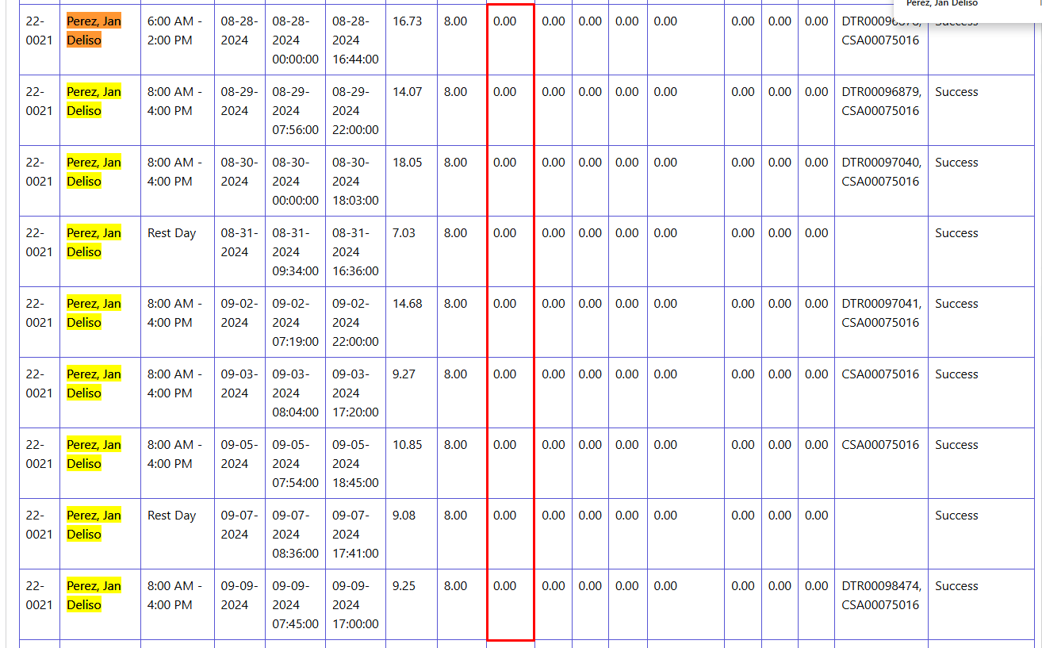

* Portugal, Jerald Opena - Aligned with the manual adjustment

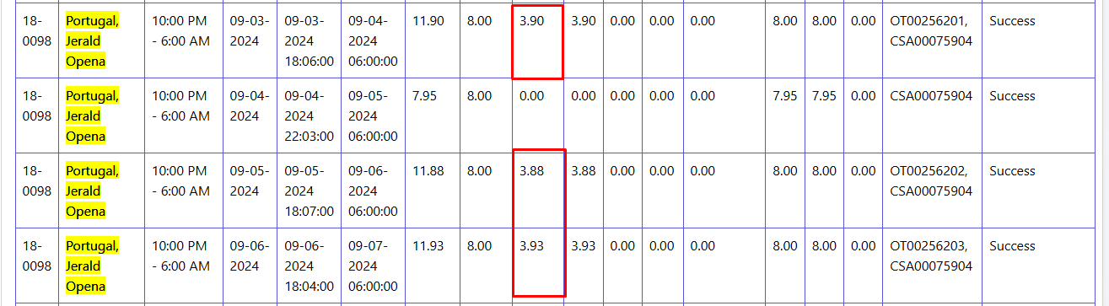



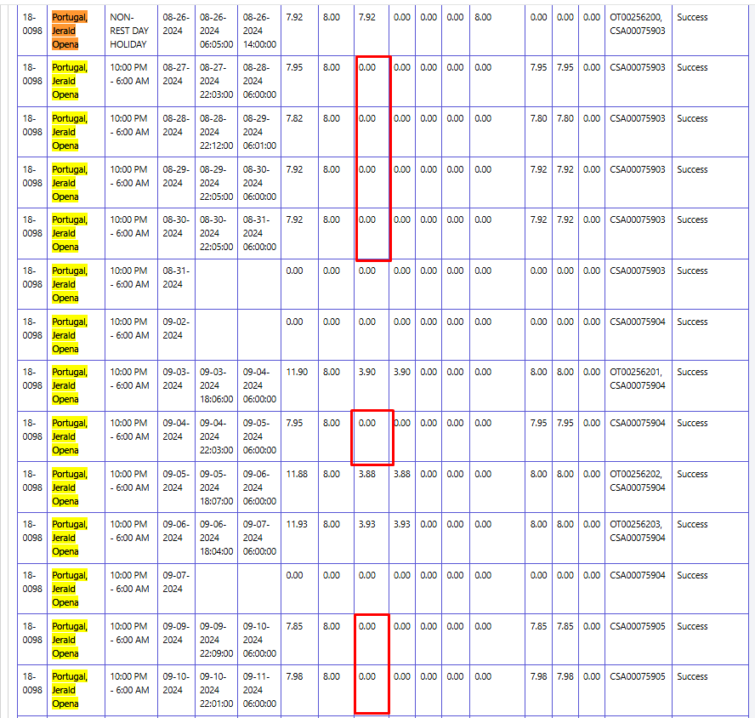Other values of the fields not reflected

* Ramos Jr., Enrique Camero - Aligned with the manual adjustment

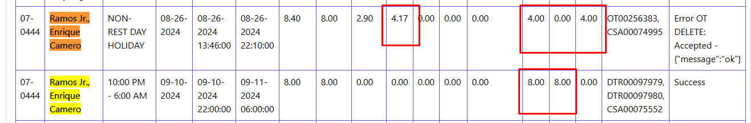

* Reyes, Direck Aguilar - Aligned with the manual adjustment

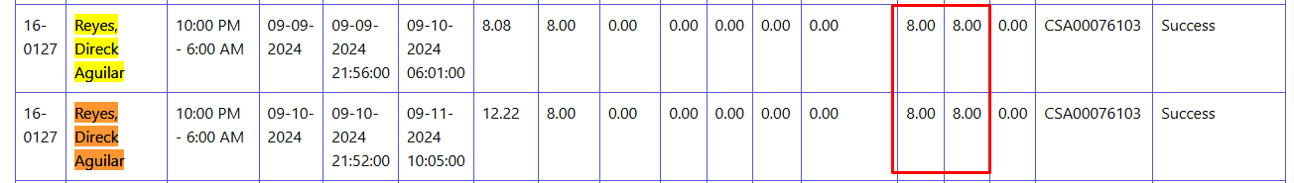

* Sanchez, Sonny CARILLO - Aligned with the manual adjustment
* Segala, Ynel Supremo - Aligned with the manual adjustment

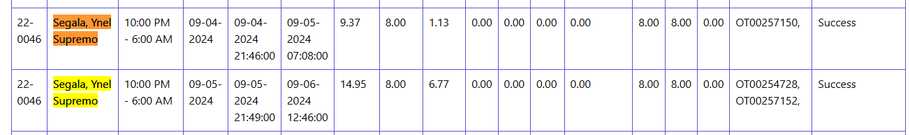

* Villaruel, Mark Vincent PERMEJO - Aligned with the manual adjustment

